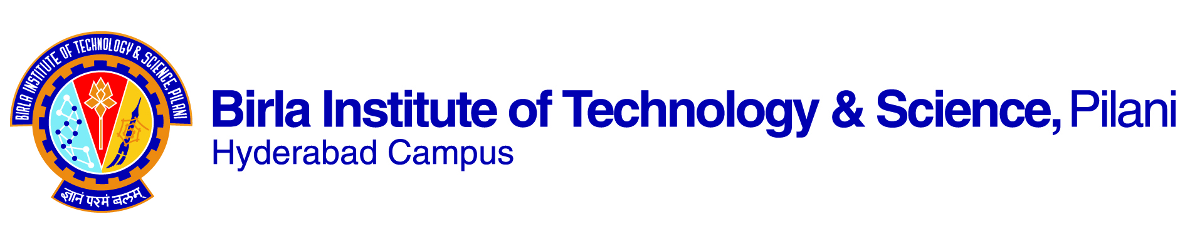

**second SEMESTER 2018-2019**

**Course Handout (Part ‑ II)**

**Date: 7.1.2019**

In addition to part‑I (General Handout for all courses appended to the time table) this portion gives further specific details regarding the course.

**Course No.: CHEM F412**

**Course Title: Photochemistry and Laser Spectroscopy**

**Instructor-in-charge: Dr. Durba Roy**

**1. Course Description**: This course is based on the exposure to theories on photophysical chemistry and LASER spectroscopy and their applications in different fields of biology/chemistry/physics. The course is normally available to students of third year onward or higher level.

**2. Scope and Objective of the Course:** Common photochemical and photophysical processes and mechanisms, interaction of excited states with their surroundings, photoinduced electron and excitation energy transfer, structure and function of photosynthetic reaction centers. Basic knowledge on the construction and function of LASERS, and its use in biophysics, chemistry, and diagnostics. The students will gain knowledge about modern lasers, spectrometers and detectors.

**3. Text Books:**

**T1:** K. K. Rohatgi-Mukherjee, Fundamentals of Photochemistry, John Wiley & Sons.

**T2:** J. R. Lakowicz, Principles of Fluorescence Spectroscopy, Springer; 3rd edition.

**T3:** W. T. Silvast, Laser Fundamentals, Cambridge University Press; 2nd edition.

*Study Materials will be provided by IC, as and when needed.*

**4. Reference Books:**

**R1:** Nicholas J. Turro, Modern Molecular Photochemistry, University Science Books, U.S.; New edition.

**5. Course Plan:**

|  |  |  |  |
| --- | --- | --- | --- |
| **No. of Lectures** | **Learning Objectives** | **Topic** | **Text Book Chapter/Sections** |
| 1-3 | Basic Laws of Photochemistry | The laws of photochemistry, potential energy surfaces, Frank Condon Principle, absorption, Beer’s law, absorption cross-section. | T1: Chapter 1; Section 1.2  T1: Chapter 4; Sections 4.3-4.5 |
| 4-6 | Photochemical Processes | Primary processes in photochemical reactions, quantum yield and lifetime. | T1: Chapter 7; Sections 7.1-7.2  T2: Chapter 1; Section 1.4 |
| 7-8 | Electronic transitions and excited state photophysics | Excited electronic states, Jablonski diagram, radiative and non-radiative transitions, vibrational relaxation, internal conversion, intersystem crossing, fluorescence, phosphorescence, excimer and exciplex. | T1: Chapter 5; Sections 5.1-5.3  T2: Chapter 1; Sections 1.1-1.4 |
| 9-12 | Excited state relaxation processes | Dynamic stokes shift, dynamic and static quenching, Stern-Volmer equation. | T2: Chapter 8; Sections 8.1-8.2.1. |
| 13-17 | Electron Transfer Reactions | Electron transfer reactions and Fluorescence Resonance Energy Transfer. | T1: Chapter 3; Sections 3.10.1-3.10.3  T2: Chapter 1; Section 1.6  T2: Chapter 13; Sections 13.1-13.2 |
| 18-19 | Solvent Effect on electronic transitions | Solvent effect on absorption and emission, Lippert equation. | T2: Chapter 6; Section 6.1-6.2.2. |
| 20-24 | Applications of Photochemical Reactions | Examples of photochemical reactions, the solar spectrum, reaction centers, photo processes in solar cells. | R1: Chapter 10; Sections 10.1-10.3  Class Notes and study materials supplied by IC |
| 25-27 | Introduction to LASER | Einstein coefficients and physical principles of laser action. Stimulated emission, population inversion and light amplification. | T1: Chapter 3; Sections 3.2-3.2.1  T3: Chapter 7; Sections 7.1-7.3 |
| 28-32 | LASER construction and functions | Construction and function of the laser, Laser types: dye lasers, continuous lasers, pulsed lasers, ultra fast lasers, semiconductor lasers. Pulsed laser: cavity dumping, Q-switching, mode locking. | T3: Chapter 5; Sections 5.2-5.4  Class Notes and study materials supplied by IC |
| 33-40 | LASER applications | Laser applications in molecular physics and chemical physics and diagnostic purposes | Class Notes and study materials supplied by IC |

**6. Evaluation Scheme:**

|  |  |  |  |  |
| --- | --- | --- | --- | --- |
| **Component** | **Weightage** | **Duration** | **Date** | **Nature of Component** |
| Midsem | 35% | 90 min | 11/3  9.00 - 10.30AM | Closed Book |
| Comprehensive | 45% | 180 min | 01/05 FN | Closed Book |
| Continuous Assessment# | 20% | - |  | Open Book |

# The instructor in class will announce the nature of assessment

**7. Chamber Consultation:** To be announced by IC.

**8. Make-Up Policy:** May be considered for genuine cases.

**9. Notices:** Will be displayed on CMS.

**10. Academic Honesty and Integrity Policy**: Academic honesty and integrity are to be maintained by all the students throughout the semester and no type of academic dishonesty is acceptable.

**Learning Outcomes:**

By the end of the course, the students should be able to

1. Consolidate the basic ideas of photochemical processes, electronic excitation and the relevant aspects of photophysics and spectroscopy.

2. Identify the varied types of excited state photochemical/photophysical processes: Fluorescence, Phosphorescence, vibrational relaxation, inter-system crossing etc.

3. Find the origin of allowed-ness/ forbidden-ness of electronic transitions.

4. Model the steady state and kinetics of excited state photochemical / photophysical processes: Electron transfer, energy transfer and proton transfer reactions.

5. Model the ubiquitous electron transfer reactions in terms of Marcus theory and the energy transfer process in terms of Forster theory.

6. Relate the photo-processes with the current research practices in the aforementioned field.

7. Apply the concepts of photochemical processes/ reactions to daily life applications: photosynthetic reaction centers in eukaryotic plants, solar cells, LEDs, LASERs etc.

8. Demonstrate how the fundamental understanding of photophysics is used up in constructing LASERs. Classify LASERs based on their types and mode of operation, applications in basic science research and biomedical investigations etc.

9. Interactive session with one Academic/Industrial expert in the field of photochemistry/LASER spectroscopy.

**Instructor-In charge**

**Durba Roy**